Step by Step to configure Oracle 12c Data Guard Physical Standby

Description:
12.1.0.2 Datagaurd setup with standby database creation using rman.

Environment Details:-
Details | Primary Server | Standby Server
Ip Address | 10.184.10.10 | 10.184.11.198
Server Name | zjdlyjrmzgm5ymz.A775741782397.AMAZONAWS.COM | ogm3odiznjaymzq.A775741782397.AMAZONAWS.COM
DB version | 12.1.0.2 | 12.1.0.2
DB Name | BSMD01 | BSMD01

Steps to be done Prior:-
- Create a database in Primary server.
- Install software binaries alone in Standby server.

Primary Server side Configurations: -

Step1: -Change Archivelog mode

SQL> archive log list;
Database log mode No Archive Mode
Automatic archival Disabled
Archive destination USE_DB_RECOVERY_FILE_DEST
Oldest online log sequence 103
Current log sequence 105
SQL> shut immediate
Database closed.
Database dismounted.
ORACLE instance shut down.
SQL> startup mount
ORACLE instance started.

Total System Global Area 2801795072 bytes
Fixed Size 8624648 bytes
Variable Size 1090520568 bytes
Database Buffers 1694498816 bytes
Redo Buffers 8151040 bytes
Database mounted.
SQL> alter database archivelog;

Database altered.

SQL> alter database open;

Database altered.

SQL> archive log list;
Database log mode Archive Mode
Automatic archival Enabled
Archive destination USE_DB_RECOVERY_FILE_DEST
Oldest online log sequence 103
Next log sequence to archive 105
Current log sequence 105
SQL> ALTER DATABASE FORCE LOGGING;

Database altered.

Step2:-Change force logging mode
SQL> ALTER DATABASE FORCE LOGGING;
Database altered.
SQL> select FORCE_LOGGING,log_mode from v$database;
FORCE_LOGGING LOG_MODE
———— ————
YES ARCHIVELOG

Step3:-Adding Redologfile for standby database

Select member from v$logfile; (to check the log file location)
SQL> alter database add standby logfile group 4 '/u02/oradata/MRPSD01/onlinelog/redo04.log' size 50m;

Database altered.

SQL> alter database add standby logfile group 5 '/u02/oradata/MRPSD01/onlinelog/redo05.log' size 50m;

Database altered.

SQL> alter database add standby logfile group 6 '/u02/oradata/MRPSD01/onlinelog/redo06.log' size 50m;

Database altered.

SQL> SELECT GROUP#,THREAD#,SEQUENCE#,ARCHIVED,STATUS FROM V$STANDBY_LOG;

GROUP# THREAD# SEQUENCE# ARC STATUS
---------- ---------- ---------- --- ----------
4 0 0 YES UNASSIGNED
5 0 0 YES UNASSIGNED
6 0 0 YES UNASSIGNED

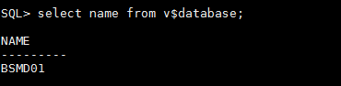
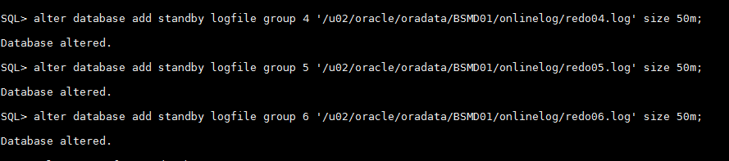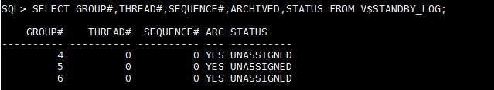

Step4:-Adding the network entry in primary and standby side(Both servers)
Primary Tnsnames entry:-
**************
cat tnsnames.ora
BSMD01 =
(DESCRIPTION =
(ADDRESS = (PROTOCOL = TCP)(HOST = 10.184.10.10)(PORT = 1526))
(CONNECT_DATA =
(SERVER = DEDICATED)
(SERVICE_NAME = BSMD01)
)
)

BSMD01S =
(DESCRIPTION =
(ADDRESS = (PROTOCOL = TCP)(HOST = 10.184.11.198)(PORT = 1526))
(CONNECT_DATA =
(SERVER = DEDICATED)
(SERVICE_NAME = BSMD01S)
)
)
Primary Listener Entry:-
************
cat listener.ora
# listener.ora Network Configuration File: /u01/app/oracle/product/12.1.0/dbhome_1/network/admin/listener.ora
# Generated by Oracle configuration tools.

LISTENER =
(DESCRIPTION_LIST =
(DESCRIPTION =
(ADDRESS = (PROTOCOL = TCP)(HOST = zjdlyjrmzgm5ymz.A775741782397.AMAZONAWS.COM)(PORT = 1526))
(ADDRESS = (PROTOCOL = IPC)(KEY = EXTPROC1526))
)
)

SID_LIST_LISTENER =
(SID_LIST =
(SID_DESC =
(GLOBAL_DBNAME = BSMD01)
(ORACLE_HOME = /u01/app/oracle/product/12.1.0/dbhome_1)
(SID_NAME = BSMD01)
)
)

INBOUND_CONNECT_TIMEOUT_LISTENER=110
SUBSCRIBE_FOR_NODE_DOWN_EVENT_LISTENER=OFF
ADR_BASE_LISTENER = /u01/app/oracle

Standby Listener Entry: -

LISTENER =
(DESCRIPTION_LIST =
(DESCRIPTION =
(ADDRESS = (PROTOCOL = TCP)(HOST = ogm3odiznjaymzq.A775741782397.AMAZONAWS.COM)(PORT = 1526))
(ADDRESS = (PROTOCOL = IPC)(KEY = EXTPROC1526))
)
)

SID_LIST_LISTENER =
(SID_LIST =
(SID_DESC =
(GLOBAL_DBNAME = BSMD01S)
(ORACLE_HOME = /u01/app/oracle/product/12.1.0/dbhome_1)
(SID_NAME = BSMD01S)
)
)

INBOUND_CONNECT_TIMEOUT_LISTENER=110
SUBSCRIBE_FOR_NODE_DOWN_EVENT_LISTENER=OFF
ADR_BASE_LISTENER = /u01/app/oracle
--------------------------------------------------
Start Listener in standby then try tnsping in both Primary and Standby

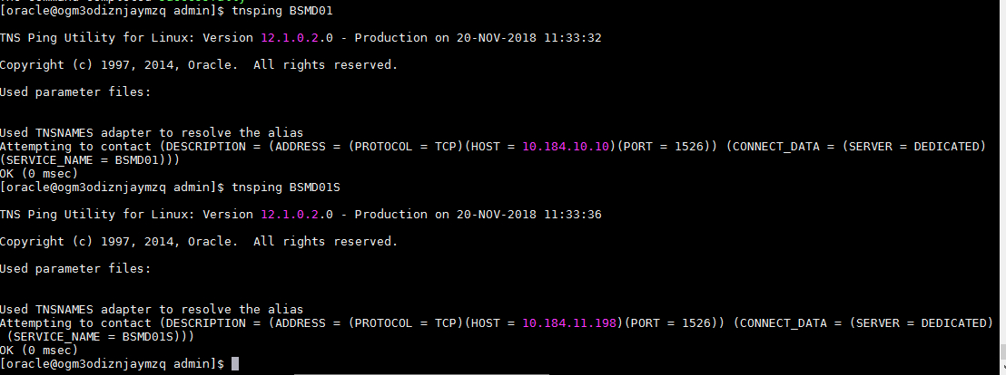

step5:-Changing parameters in primary database
SQL> ALTER SYSTEM SET db_unique_name='BSMD01' SCOPE=SPFILE;

System altered.

SQL> ALTER SYSTEM SET log_archive_config='dg_config=(BSMD01,BSMD01S)' SCOPE=SPFILE;

System altered.

SQL> ALTER SYSTEM SET log_archive_dest_1='location=use_db_recovery_file_dest valid_for=(all_logfiles,all_roles) db_unique_name=BSMD01' SCOPE=SPFILE;

System altered.

SQL> ALTER SYSTEM SET log_archive_dest_2='service=BSMD01S async valid_for=(online_logfiles,primary_role) db_unique_name=BSMD01S' SCOPE=SPFILE;

System altered.

SQL> ALTER SYSTEM SET fal_server='BSMD01S' SCOPE=SPFILE;

System altered.

SQL> ALTER SYSTEM SET fal_client='BSMD01' SCOPE=SPFILE;

System altered.

SQL> ALTER SYSTEM SET standby_file_management='AUTO' SCOPE=SPFILE;

System altered.

SQL> ALTER SYSTEM SET db_file_name_convert='/u02/oracle/oradata/BSMD01S','/u02/oracle/oradata/BSMD01' SCOPE=SPFILE;

System altered.

SQL> ALTER SYSTEM SET log_file_name_convert='/u02/oracle/oradata/BSMD01S/onlinelog/','/u02/oracle/oradata/BSMD01/onlinelog/' SCOPE=SPFILE;

System altered.

Standby Server side Configurations:-

Step1:- Password file creation
From primary copy and put the file in standby:
[oracle@zjdlyjrmzgm5ymz dbhome_1]$ cd dbs
[oracle@zjdlyjrmzgm5ymz dbs]$ ls -ltr
total 40
-rw-r--r--. 1 oracle oinstall 2992 Feb 3 2012 init.ora
-rw-r-----. 1 oracle oinstall 24 Nov 1 14:47 lkBSMD01
-rw-r-----. 1 oracle oinstall 7680 Nov 1 15:04 orapwBSMD01_old
-rw-r-----. 1 oracle oinstall 7680 Nov 2 16:27 orapwBSMD01
-rw-r--r--. 1 oracle oinstall 1125 Nov 6 11:42 initBSMD01.ora
-rw-rw----. 1 oracle oinstall 1544 Nov 20 11:02 hc_BSMD01.dat
-rw-r-----. 1 oracle oinstall 4608 Nov 20 12:02 spfileBSMD01.ora

[oracle@zjdlyjrmzgm5ymz dbs]$ scp orapwBSMD01 oracle@10.184.11.198:/u01/app/oracle/product/12.1.0/dbhome_1/dbs/
Password:
orapwBSMD01 100% 7680 1.9MB/s 00:00
[oracle@zjdlyjrmzgm5ymz dbs]$
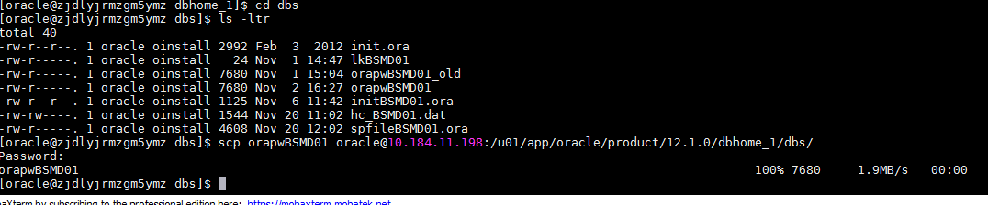

Change the password file name in standby
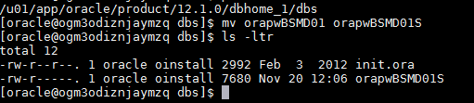

Step2:- Changing parameters in standby database
In the $ORACLE_HOME/dbs directory of the standby system, create an initialization parameter


Step3:- Create directory Structure in Standby database
Check the directories of datafiles and logfiles.
Select name from v$datafile;
Select member from v$logfile;
[oracle@ogm3odiznjaymzq oracle]$ pwd
/u01/app/oracle
[oracle@ogm3odiznjaymzq oracle]$ mkdir admin
[oracle@ogm3odiznjaymzq oracle]$ ls -ltr
total 16
[oracle@ogm3odiznjaymzq admin]$ mkdir BSMD01S
[oracle@ogm3odiznjaymzq admin]$ cd BSMD01S/
[oracle@ogm3odiznjaymzq BSMD01S]$ mkdir adump pfile dpdump
[oracle@ogm3odiznjaymzq /]$ cd $ORACLE_BASE
[oracle@ogm3odiznjaymzq oracle]$ pwd
/u01/app/oracle
[oracle@ogm3odiznjaymzq oracle]$ ls -ltr
total 16
drwxr-xr-x. 3 oracle oinstall 4096 Nov 20 10:43 product
drwxrwxr-x. 19 oracle oinstall 4096 Nov 20 10:47 diag
drwxr-xr-x. 2 oracle oinstall 4096 Nov 20 10:50 checkpoints
drwxr-xr-x. 3 oracle oinstall 4096 Nov 20 12:27 admin
[oracle@ogm3odiznjaymzq oracle]$ mkdir -p fast_recovery_area/BSMD01S/archivelog
[oracle@ogm3odiznjaymzq oracle]$ ls -ltr
total 20
db_recovery_file_dest='/u01/app/oracle/fast_recovery_area/ BSMD01S /archivelog'

Step4:- start the standby database using pfile

export ORACLE_BASE=/u01/app/oracle
export ORACLE_HOME=/u01/app/oracle/product/12.1.0/dbhome_1/
export PATH=$PATH:$ORACLE_HOME/bin
export ORACLE_SID=BSMD01S

[oracle@ogm3odiznjaymzq dbs]$ sqlplus / as sysdba

SQL*Plus: Release 12.1.0.2.0 Production on Tue Nov 20 12:34:23 2018

Copyright (c) 1982, 2014, Oracle. All rights reserved.

Connected to an idle instance.

SQL> startup pfile= 'initMRPSPP01S.ora' nomount;
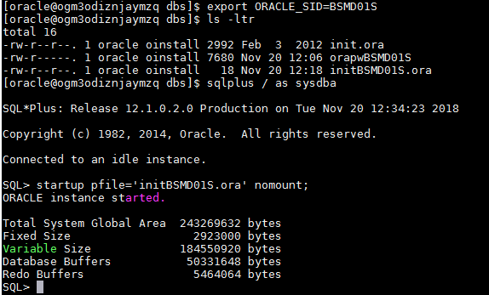

Step5:- connect to the rman

Connect with Primary oracle sid and run the rman commands in standby.
export ORACLE_SID=BSMD01
rman target sys/oracle123@BSMD01
connect auxiliary sys/oracle123@MRPSPP1S

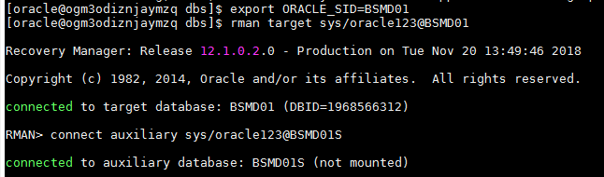
RMAN> run
{
allocate channel p1 type disk;
allocate channel p2 type disk;
allocate channel p3 type disk;
allocate channel p4 type disk;
allocate auxiliary channel s1 type disk;
duplicate target database for standby from active database
spfile
parameter_value_convert 'BSMD01','BSMD01S'
set db_name='BSMD01'
set db_unique_name='BSMD01S'
set db_file_name_convert='/u02/oracle/oradata/BSMD01/','/u02/oracle/oradata/BSMD01S/'
set log_file_name_convert='/u02/oracle/oradata/BSMD01/onlinelog','/u02/oracle/oradata/BSMD01S/onlinelog'
set control_files='/u02/oracle/oradata/BSMD01S/onlinelog/standby1.ctl'
set log_archive_max_processes='5'
set fal_client='BSMD01S'
set fal_server='BSMD01'
set standby_file_management='AUTO'
set log_archive_config='dg_config=(BSMD01,BSMD01S)'
set compatible='12.1.0.2.0'
set sga_target='4765m'
set pga_aggregate_target='1588m'
nofilenamecheck;
}2> 3> 4> 5> 6> 7> 8> 9> 10> 11> 12> 13> 14> 15> 16> 17> 18> 19> 20> 21> 22> 23> 24> 25>

using target database control file instead of recovery catalog
allocated channel: p1
channel p1: SID=13 device type=DISK

allocated channel: p2
channel p2: SID=581 device type=DISK

allocated channel: p3
channel p3: SID=1152 device type=DISK

allocated channel: p4
channel p4: SID=1715 device type=DISK

allocated channel: s1
channel s1: SID=87 device type=DISK

Starting Duplicate Db at 20-NOV-18

contents of Memory Script:
{
backup as copy reuse
targetfile '/u01/app/oracle/product/12.1.0/dbhome_1/dbs/orapwBSMD01' auxiliary format
'/u01/app/oracle/product/12.1.0/dbhome_1/dbs/orapwBSMD01S' targetfile
'/u01/app/oracle/product/12.1.0/dbhome_1/dbs/spfileBSMD01.ora' auxiliary format
'/u01/app/oracle/product/12.1.0/dbhome_1/dbs/spfileBSMD01S.ora' ;
sql clone "alter system set spfile= ''/u01/app/oracle/product/12.1.0/dbhome_1/dbs/spfileBSMD01S.ora''";
}
executing Memory Script

Starting backup at 20-NOV-18
Finished backup at 20-NOV-18

sql statement: alter system set spfile= ''/u01/app/oracle/product/12.1.0/dbhome_1/dbs/spfileBSMD01S.ora''

contents of Memory Script:
{
sql clone "alter system set audit_file_dest =
''/u01/app/oracle/admin/BSMD01S/adump'' comment=
'''' scope=spfile";
sql clone "alter system set dispatchers =
''(PROTOCOL=TCP) (SERVICE=BSMD01SXDB)'' comment=
'''' scope=spfile";
sql clone "alter system set log_archive_dest_1 =
''location=use_db_recovery_file_dest valid_for=(all_logfiles,all_roles) db_unique_name=BSMD01S'' comment=
'''' scope=spfile";
sql clone "alter system set log_archive_dest_2 =
''service=BSMD01SS async valid_for=(online_logfiles,primary_role) db_unique_name=BSMD01S'' comment=
'''' scope=spfile";
sql clone "alter system set db_name =
''BSMD01'' comment=
'''' scope=spfile";
sql clone "alter system set db_unique_name =
''BSMD01S'' comment=
'''' scope=spfile";
sql clone "alter system set db_file_name_convert =
''/u02/oracle/oradata/BSMD01/'', ''/u02/oracle/oradata/BSMD01S/'' comment=
'''' scope=spfile";
sql clone "alter system set log_file_name_convert =
''/u02/oracle/oradata/BSMD01/onlinelog'', ''/u02/oracle/oradata/BSMD01S/onlinelog'' comment=
'''' scope=spfile";
sql clone "alter system set control_files =
''/u02/oracle/oradata/BSMD01S/onlinelog/standby1.ctl'' comment=
'''' scope=spfile";
sql clone "alter system set log_archive_max_processes =
5 comment=
'''' scope=spfile";
sql clone "alter system set fal_client =
''BSMD01S'' comment=
'''' scope=spfile";
sql clone "alter system set fal_server =
''BSMD01'' comment=
'''' scope=spfile";
sql clone "alter system set standby_file_management =
''AUTO'' comment=
'''' scope=spfile";
sql clone "alter system set log_archive_config =
''dg_config=(BSMD01,BSMD01S)'' comment=
'''' scope=spfile";
sql clone "alter system set compatible =
''12.1.0.2.0'' comment=
'''' scope=spfile";
sql clone "alter system set sga_target =
4765m comment=
'''' scope=spfile";
sql clone "alter system set pga_aggregate_target =
1588m comment=
'''' scope=spfile";
shutdown clone immediate;
startup clone nomount;
}
executing Memory Script

sql statement: alter system set audit_file_dest = ''/u01/app/oracle/admin/BSMD01S/adump'' comment= '''' scope=spfile

sql statement: alter system set dispatchers = ''(PROTOCOL=TCP) (SERVICE=BSMD01SXDB)'' comment= '''' scope=spfile

sql statement: alter system set log_archive_dest_1 = ''location=use_db_recovery_file_dest valid_for=(all_logfiles,all_roles) db_unique_name=BSMD01S'' comment= '''' scope=spfile

sql statement: alter system set log_archive_dest_2 = ''service=BSMD01SS async valid_for=(online_logfiles,primary_role) db_unique_name=BSMD01S'' comment= '''' scope=spfile

sql statement: alter system set db_name = ''BSMD01'' comment= '''' scope=spfile

sql statement: alter system set db_unique_name = ''BSMD01S'' comment= '''' scope=spfile

sql statement: alter system set db_file_name_convert = ''/u02/oracle/oradata/BSMD01/'', ''/u02/oracle/oradata/BSMD01S/'' comment= '''' scope=spfile

sql statement: alter system set log_file_name_convert = ''/u02/oracle/oradata/BSMD01/onlinelog'', ''/u02/oracle/oradata/BSMD01S/onlinelog'' comment= '''' scope=spfile

sql statement: alter system set control_files = ''/u02/oracle/oradata/BSMD01S/onlinelog/standby1.ctl'' comment= '''' scope=spfile

sql statement: alter system set log_archive_max_processes = 5 comment= '''' scope=spfile

sql statement: alter system set fal_client = ''BSMD01S'' comment= '''' scope=spfile

sql statement: alter system set fal_server = ''BSMD01'' comment= '''' scope=spfile

sql statement: alter system set standby_file_management = ''AUTO'' comment= '''' scope=spfile

sql statement: alter system set log_archive_config = ''dg_config=(BSMD01,BSMD01S)'' comment= '''' scope=spfile

sql statement: alter system set compatible = ''12.1.0.2.0'' comment= '''' scope=spfile

sql statement: alter system set sga_target = 4765m comment= '''' scope=spfile

sql statement: alter system set pga_aggregate_target = 1588m comment= '''' scope=spfile

Oracle instance shut down

connected to auxiliary database (not started)
Oracle instance started

Total System Global Area 4999610368 bytes

Fixed Size 2934648 bytes
Variable Size 1442842760 bytes
Database Buffers 3539992576 bytes
Redo Buffers 13840384 bytes
allocated channel: s1
channel s1: SID=6 device type=DISK

contents of Memory Script:
{
backup as copy current controlfile for standby auxiliary format '/u02/oracle/oradata/BSMD01S/onlinelog/standby1.ctl';
}
executing Memory Script

Starting backup at 20-NOV-18
channel p1: starting datafile copy
copying standby control file
output file name=/u01/app/oracle/product/12.1.0/dbhome_1/dbs/snapcf_BSMD01.f tag=TAG20181120T135041
channel p1: datafile copy complete, elapsed time: 00:00:01
Finished backup at 20-NOV-18

contents of Memory Script:
{
sql clone 'alter database mount standby database';
}
executing Memory Script

sql statement: alter database mount standby database

contents of Memory Script:
{
set newname for tempfile 1 to
"/u02/oracle/oradata/BSMD01S/temp01.dbf";
switch clone tempfile all;
set newname for datafile 1 to
"/u02/oracle/oradata/BSMD01S/system01.dbf";
set newname for datafile 2 to
"/u02/oracle/oradata/BSMD01S/XDB.dbf";
set newname for datafile 3 to
"/u02/oracle/oradata/BSMD01S/sysaux01.dbf";
set newname for datafile 4 to
"/u02/oracle/oradata/BSMD01S/undotbs01.dbf";
set newname for datafile 5 to
"/u02/oracle/oradata/BSMD01S/SYSAUD.dbf";
set newname for datafile 6 to
"/u02/oracle/oradata/BSMD01S/users01.dbf";
set newname for datafile 7 to
"/u02/oracle/oradata/BSMD01S/SGMS_INDEX_M.dbf";
set newname for datafile 8 to
"/u02/oracle/oradata/BSMD01S/SGMS_INDEX_L.dbf";
set newname for datafile 9 to
"/u02/oracle/oradata/BSMD01S/SGMS_INDEX_S.dbf";
set newname for datafile 10 to
"/u02/oracle/oradata/BSMD01S/SGMS_DATA_L.dbf";
set newname for datafile 11 to
"/u02/oracle/oradata/BSMD01S/SGMS_DATA_S.dbf";
set newname for datafile 12 to
"/u02/oracle/oradata/BSMD01S/SGMS_DATA_M.dbf";
set newname for datafile 13 to
"/u02/oracle/oradata/BSMD01S/users02.dbf";
set newname for datafile 14 to
"/u02/oracle/oradata/BSMD01S/SGMS_INDEX_L01.dbf";
set newname for datafile 15 to
"/u02/oracle/oradata/BSMD01S/SGMS_DATA_L01.dbf";
backup as copy reuse
datafile 1 auxiliary format
"/u02/oracle/oradata/BSMD01S/system01.dbf" datafile
2 auxiliary format
"/u02/oracle/oradata/BSMD01S/XDB.dbf" datafile
3 auxiliary format
"/u02/oracle/oradata/BSMD01S/sysaux01.dbf" datafile
4 auxiliary format
"/u02/oracle/oradata/BSMD01S/undotbs01.dbf" datafile
5 auxiliary format
"/u02/oracle/oradata/BSMD01S/SYSAUD.dbf" datafile
6 auxiliary format
"/u02/oracle/oradata/BSMD01S/users01.dbf" datafile
7 auxiliary format
"/u02/oracle/oradata/BSMD01S/SGMS_INDEX_M.dbf" datafile
8 auxiliary format
"/u02/oracle/oradata/BSMD01S/SGMS_INDEX_L.dbf" datafile
9 auxiliary format
"/u02/oracle/oradata/BSMD01S/SGMS_INDEX_S.dbf" datafile
10 auxiliary format
"/u02/oracle/oradata/BSMD01S/SGMS_DATA_L.dbf" datafile
11 auxiliary format
"/u02/oracle/oradata/BSMD01S/SGMS_DATA_S.dbf" datafile
12 auxiliary format
"/u02/oracle/oradata/BSMD01S/SGMS_DATA_M.dbf" datafile
13 auxiliary format
"/u02/oracle/oradata/BSMD01S/users02.dbf" datafile
14 auxiliary format
"/u02/oracle/oradata/BSMD01S/SGMS_INDEX_L01.dbf" datafile
15 auxiliary format
"/u02/oracle/oradata/BSMD01S/SGMS_DATA_L01.dbf" ;
sql 'alter system archive log current';
}
executing Memory Script

executing command: SET NEWNAME

renamed tempfile 1 to /u02/oracle/oradata/BSMD01S/temp01.dbf in control file

executing command: SET NEWNAME

executing command: SET NEWNAME

executing command: SET NEWNAME

executing command: SET NEWNAME

executing command: SET NEWNAME

executing command: SET NEWNAME

executing command: SET NEWNAME

executing command: SET NEWNAME

executing command: SET NEWNAME

executing command: SET NEWNAME

executing command: SET NEWNAME

executing command: SET NEWNAME

executing command: SET NEWNAME

executing command: SET NEWNAME

executing command: SET NEWNAME

Starting backup at 20-NOV-18
channel p1: starting datafile copy
input datafile file number=00011 name=/u02/oracle/oradata/BSMD01/SGMS_DATA_S.dbf
channel p2: starting datafile copy
input datafile file number=00010 name=/u02/oracle/oradata/BSMD01/SGMS_DATA_L.dbf
channel p3: starting datafile copy
input datafile file number=00008 name=/u02/oracle/oradata/BSMD01/SGMS_INDEX_L.dbf
channel p4: starting datafile copy
input datafile file number=00014 name=/u02/oracle/oradata/BSMD01/SGMS_INDEX_L01.dbf
output file name=/u02/oracle/oradata/BSMD01S/SGMS_INDEX_L01.dbf tag=TAG20181120T135048
channel p4: datafile copy complete, elapsed time: 00:04:17
channel p4: starting datafile copy
input datafile file number=00009 name=/u02/oracle/oradata/BSMD01/SGMS_INDEX_S.dbf
output file name=/u02/oracle/oradata/BSMD01S/SGMS_DATA_S.dbf tag=TAG20181120T135048
channel p1: datafile copy complete, elapsed time: 00:06:42
channel p1: starting datafile copy
input datafile file number=00015 name=/u02/oracle/oradata/BSMD01/SGMS_DATA_L01.dbf
output file name=/u02/oracle/oradata/BSMD01S/SGMS_DATA_L01.dbf tag=TAG20181120T135048
channel p1: datafile copy complete, elapsed time: 00:01:25
channel p1: starting datafile copy
input datafile file number=00002 name=/u02/oracle/oradata/BSMD01/XDB.dbf
output file name=/u02/oracle/oradata/BSMD01S/SGMS_INDEX_L.dbf tag=TAG20181120T135048
channel p3: datafile copy complete, elapsed time: 00:08:11
channel p3: starting datafile copy
input datafile file number=00005 name=/u02/oracle/oradata/BSMD01/SYSAUD.dbf
output file name=/u02/oracle/oradata/BSMD01S/XDB.dbf tag=TAG20181120T135048
channel p1: datafile copy complete, elapsed time: 00:01:08
channel p1: starting datafile copy
input datafile file number=00007 name=/u02/oracle/oradata/BSMD01/SGMS_INDEX_M.dbf
output file name=/u02/oracle/oradata/BSMD01S/SYSAUD.dbf tag=TAG20181120T135048
channel p3: datafile copy complete, elapsed time: 00:01:05
channel p3: starting datafile copy
input datafile file number=00012 name=/u02/oracle/oradata/BSMD01/SGMS_DATA_M.dbf
output file name=/u02/oracle/oradata/BSMD01S/SGMS_INDEX_S.dbf tag=TAG20181120T135048
channel p4: datafile copy complete, elapsed time: 00:05:07
channel p4: starting datafile copy
input datafile file number=00013 name=/u02/oracle/oradata/BSMD01/users02.dbf
output file name=/u02/oracle/oradata/BSMD01S/SGMS_DATA_L.dbf tag=TAG20181120T135048
channel p2: datafile copy complete, elapsed time: 00:09:40
channel p2: starting datafile copy
input datafile file number=00003 name=/u02/oracle/oradata/BSMD01/sysaux01.dbf
output file name=/u02/oracle/oradata/BSMD01S/SGMS_INDEX_M.dbf tag=TAG20181120T135048
channel p1: datafile copy complete, elapsed time: 00:01:09
channel p1: starting datafile copy
input datafile file number=00001 name=/u02/oracle/oradata/BSMD01/system01.dbf
output file name=/u02/oracle/oradata/BSMD01S/sysaux01.dbf tag=TAG20181120T135048
channel p2: datafile copy complete, elapsed time: 00:00:46
channel p2: starting datafile copy
input datafile file number=00004 name=/u02/oracle/oradata/BSMD01/undotbs01.dbf
output file name=/u02/oracle/oradata/BSMD01S/SGMS_DATA_M.dbf tag=TAG20181120T135048
channel p3: datafile copy complete, elapsed time: 00:01:09
channel p3: starting datafile copy
input datafile file number=00006 name=/u02/oracle/oradata/BSMD01/users01.dbf
output file name=/u02/oracle/oradata/BSMD01S/users02.dbf tag=TAG20181120T135048
channel p4: datafile copy complete, elapsed time: 00:01:02
output file name=/u02/oracle/oradata/BSMD01S/users01.dbf tag=TAG20181120T135048
channel p3: datafile copy complete, elapsed time: 00:00:01
output file name=/u02/oracle/oradata/BSMD01S/undotbs01.dbf tag=TAG20181120T135048
channel p2: datafile copy complete, elapsed time: 00:00:07
output file name=/u02/oracle/oradata/BSMD01S/system01.dbf tag=TAG20181120T135048
channel p1: datafile copy complete, elapsed time: 00:00:25
Finished backup at 20-NOV-18

sql statement: alter system archive log current

contents of Memory Script:
{
switch clone datafile all;
}
executing Memory Script

datafile 1 switched to datafile copy
input datafile copy RECID=1 STAMP=992700100 file name=/u02/oracle/oradata/BSMD01S/system01.dbf
datafile 2 switched to datafile copy
input datafile copy RECID=2 STAMP=992700100 file name=/u02/oracle/oradata/BSMD01S/XDB.dbf
datafile 3 switched to datafile copy
input datafile copy RECID=3 STAMP=992700100 file name=/u02/oracle/oradata/BSMD01S/sysaux01.dbf
datafile 4 switched to datafile copy
input datafile copy RECID=4 STAMP=992700100 file name=/u02/oracle/oradata/BSMD01S/undotbs01.dbf
datafile 5 switched to datafile copy
input datafile copy RECID=5 STAMP=992700100 file name=/u02/oracle/oradata/BSMD01S/SYSAUD.dbf
datafile 6 switched to datafile copy
input datafile copy RECID=6 STAMP=992700100 file name=/u02/oracle/oradata/BSMD01S/users01.dbf
datafile 7 switched to datafile copy
input datafile copy RECID=7 STAMP=992700100 file name=/u02/oracle/oradata/BSMD01S/SGMS_INDEX_M.dbf
datafile 8 switched to datafile copy
input datafile copy RECID=8 STAMP=992700100 file name=/u02/oracle/oradata/BSMD01S/SGMS_INDEX_L.dbf
datafile 9 switched to datafile copy
input datafile copy RECID=9 STAMP=992700100 file name=/u02/oracle/oradata/BSMD01S/SGMS_INDEX_S.dbf
datafile 10 switched to datafile copy
input datafile copy RECID=10 STAMP=992700100 file name=/u02/oracle/oradata/BSMD01S/SGMS_DATA_L.dbf
datafile 11 switched to datafile copy
input datafile copy RECID=11 STAMP=992700100 file name=/u02/oracle/oradata/BSMD01S/SGMS_DATA_S.dbf
datafile 12 switched to datafile copy
input datafile copy RECID=12 STAMP=992700100 file name=/u02/oracle/oradata/BSMD01S/SGMS_DATA_M.dbf
datafile 13 switched to datafile copy
input datafile copy RECID=13 STAMP=992700100 file name=/u02/oracle/oradata/BSMD01S/users02.dbf
datafile 14 switched to datafile copy
input datafile copy RECID=14 STAMP=992700100 file name=/u02/oracle/oradata/BSMD01S/SGMS_INDEX_L01.dbf
datafile 15 switched to datafile copy
input datafile copy RECID=15 STAMP=992700100 file name=/u02/oracle/oradata/BSMD01S/SGMS_DATA_L01.dbf
Finished Duplicate Db at 20-NOV-18
released channel: p1
released channel: p2
released channel: p3
released channel: p4
released channel: s1

RMAN> exit

Recovery Manager complete.

Step6:- connect to the standby database
Connect to standby database oracle sid
[oracle@nge2mzy0zdrjntf dbs]$ export ORACLE_SID=BSMD01S
[oracle@nge2mzy0zdrjntf dbs]$
[oracle@nge2mzy0zdrjntf dbs]$ sqlplus "/ as sysdba"

SQL*Plus: Release 12.2.0.1.0 Production on Fri Nov 16 12:56:48 2018

Copyright (c) 1982, 2016, Oracle. All rights reserved.

Connected to:
Oracle Database 12c Enterprise Edition Release 12.2.0.1.0 - 64bit Production

SQL> select name,open_mode from v$database;

NAME OPEN_MODE
--------- --------------------
BSMD01 MOUNTED
Start MRP process.
SQL> alter database recover managed standby database using current logfile disconnect;

Database altered.
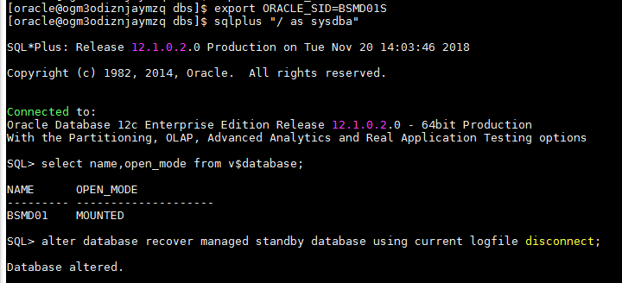

Step7:- Physical Standby Database is Performing Correctly

SQL> SELECT sequence#, first_time, next_time, applied FROM v$archived_log ORDER BY sequence#;

SEQUENCE# FIRST_TIM NEXT_TIME APPLIED
---------- --------- --------- ---------
107 20-NOV-18 20-NOV-18 YES
108 20-NOV-18 20-NOV-18 YES
109 20-NOV-18 20-NOV-18 YES
110 20-NOV-18 20-NOV-18 YES
111 20-NOV-18 20-NOV-18 YES
112 20-NOV-18 20-NOV-18 IN-MEMORY

6 rows selected.
Successfully configured the Oracle 12c Data Guard Physical Standby

USEFUL COMMANDS: –

To stop the archive logs getting shipped to standby –

ALTER SYSTEM SET LOG_ARCHIVE_DEST_STATE_2='DEFER' SCOPE=BOTH SID='*';

To start the archive logs getting shipped to standby –

ALTER SYSTEM SET LOG_ARCHIVE_DEST_STATE_2='ENABLE' SCOPE=BOTH SID='*';

To start the MRP process in Standby database –

ALTER DATABASE RECOVER MANAGED STANDBY DATABASE DISCONNECT;

To stop the MRP process in Standby database –

ALTER DATABASE RECOVER MANAGED STANDBY DATABASE CANCEL;

To verify the logs shipped to the standby site from Primary site –

SELECT THREAD#,MAX(SEQUENCE#) FROM V$ARCHIVED_LOG WHERE ARCHIVED='YES' AND DEST_ID=2 GROUP BY THREAD# order by 1;

To verify the logs applied to the standby site –

SELECT THREAD#,MAX(SEQUENCE#) FROM V$ARCHIVED_LOG WHERE APPLIED='YES' GROUP BY THREAD# order by 1;

To check if there is any gap in the archive logs – ( will take up to 5 mins)

SELECT THREAD#, LOW_SEQUENCE#, HIGH_SEQUENCE# FROM V$ARCHIVE_GAP;

